Dear Homeowner,

I would like to introduce myself, I am Doug Minton and I work for Realty ONE Group Legend. Our company is in 16 States, we have 8000+ Agents, and we are the Fastest Growing Real Estate Franchise according to INC 500.

We are very familiar with this area and have been doing many searches for properties for our clients. All of our clients are very well-qualified and serious buyers. Unfortunately, we have been unable to find just the right home in this area. I came across your lovely home and wondered if perhaps you are considering selling? Even if you aren’t looking to sell right now and you are just wondering what the value on your home is, I would be happy to prepare a Comparative Market Analysis for you.

If I can be of assistance in any way, please do not hesitate to contact me at my information listed below.

Sincerely,
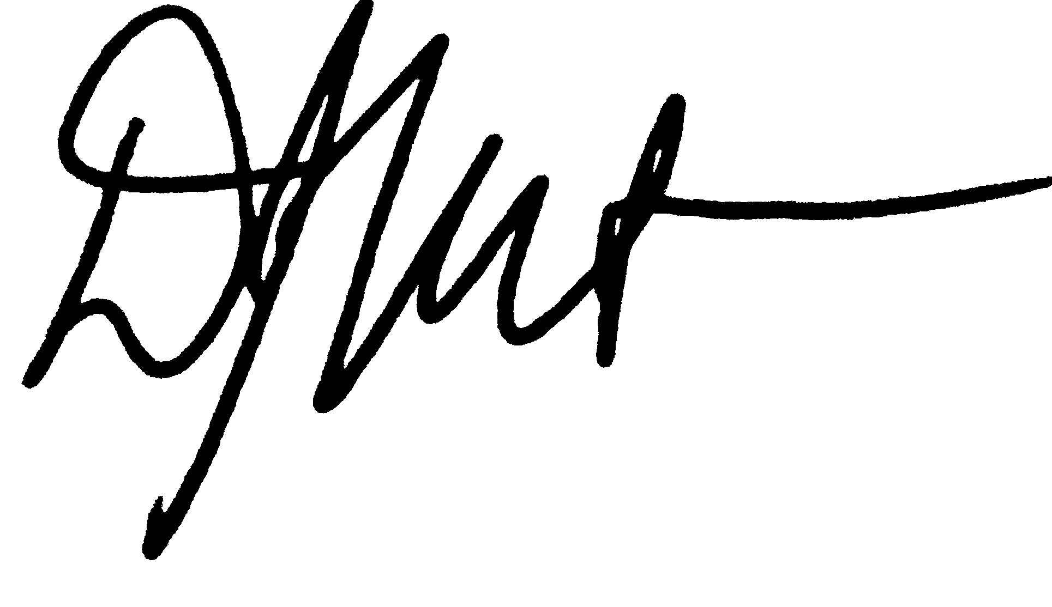

Douglas Minton (Sales Associate) RealtyONEGroup Legend dminton@roglegend.com
Direct: 877-349-4597
Office: 973-686-7777

